**Introduction To**

**Simulink**

**LAB # 12**



**Spring 2023**

**CSE301L Signals & Systems Lab**

Submitted by: **Suleman Shah**

Registration No. : **21PWCSE1983**

Class Section: **C**

“On my honor, as student of University of Engineering and Technology, I have neither given nor received unauthorized assistance on this academic work.”

Submitted to:

**Engr. Sumayyea Salahuddin**

Date:

**June 13, 2023**

**Department of Computer Systems Engineering**

**University of Engineering and Technology, Peshawar**

## Lab Objective(s):

Objectives of this Lab are;

* Understanding and introduction to Simulink, an extension to Matlab.

**Introduction:**

Simulink is a powerful tool widely used for modeling, simulating, and analyzing dynamic systems. It provides an intuitive graphical environment for building complex models using block diagrams. This lab report focuses on implementing the synthesis of a square wave using Fourier series within Simulink. The Fourier series is a mathematical technique that represents periodic functions as a sum of harmonic sine and cosine functions. The square wave, a periodic waveform with abrupt transitions between high and low levels, serves as an ideal example for understanding the concept of Fourier series synthesis.

**Theory:**

The Fourier series representation of a periodic function f(t) with a fundamental period T can be expressed as follows:

$$f\left(x\right)=a_{0}+\sum_{n=1}^{∞}{\left(a_{n}\cos{nω0x}+b_{n}\sin{nω0x}\right)}$$

Where:

* f(t) is the periodic function
* a0 is the DC component
* an and bn are the coefficients of the cosine and sine terms, respectively
* n is the harmonic number
* ω0 = 2π/T is the angular frequency

For a square wave, the Fourier series coefficients are calculated as follows:

**Simulink Implementation**

In Simulink, we can utilize various blocks to create a model that implements the synthesis of a square wave using Fourier series. The following steps outline the

procedure:

**Step 1:** Create a new Simulink model.

**Step 2:** Add a sine wave block to generate the fundamental frequency, ω0.

**Step 3:** Implement the series summation using a summation block and a series of cosine and sine wave blocks.

**Step 4:** Set the amplitudes of the cosine and sine waves according to the Fourier series coefficients.

**Step 5:** Connect the blocks appropriately to form the desired structure.

**Step 6:** Configure the simulation parameters, such as the simulation time and sample rate.

**Step 7:** Run the simulation and observe the synthesized square wave output.

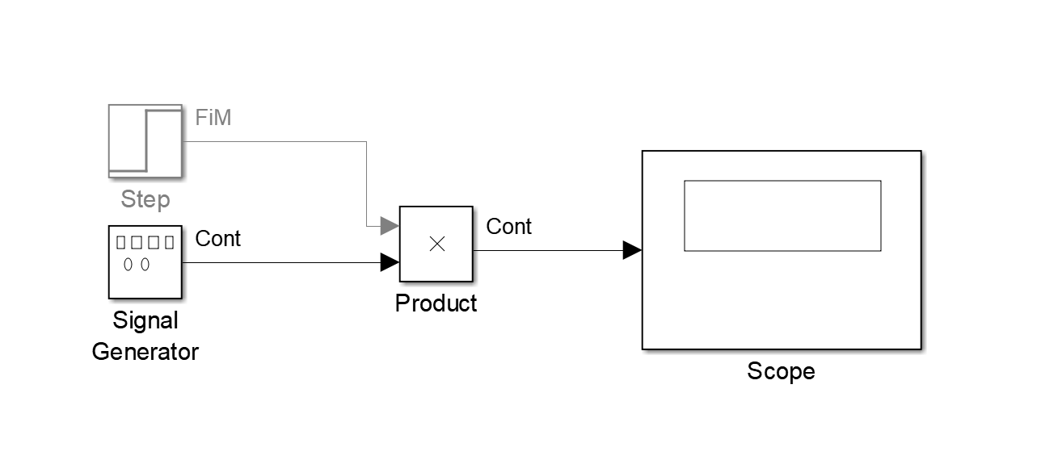

Figure 1-1: Causal System in Simulink

**Results and Observations**

After implementing the Simulink model for square wave synthesis using Fourier series, we can observe the following:

* The synthesized square wave consists of multiple harmonic components, each contributing to the overall waveform shape.
* As we increase the number of harmonic components used in the series summation, the synthesized square wave more closely resembles the ideal square wave.
* The amplitudes of the harmonic components decrease as the harmonic number increases, resulting in a smoother square wave representation.

Figure 1-2: Causal System in Simulink

**Conclusion**

Simulink provides an efficient and intuitive platform for implementing complex systems and signal processing techniques. In this lab report, we successfully synthesized a square wave using Fourier series in Simulink, demonstrating the power and versatility of the software. By visualizing the harmonic components, we gained insight into the process of signal synthesis and the importance of Fourier series in analyzing periodic waveforms. Simulink can serve as a valuable tool for engineers and researchers working in diverse fields, allowing them to design and analyze dynamic systems effectively.